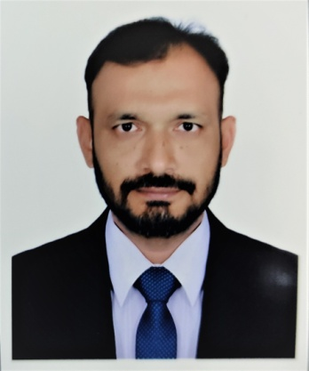Md. Kawsar Hossain khan

House- 34/3B (3rd Floor), Nobodoy Housing, Mohammadpur, Dhaka

**Cell: +88 01312809597**

E-mail: [saykawsarkhan@gmail.com](mailto:saykawsarkhan@gmail.com)

…………………………………………………………..

**CAREER OBJECTIVE**

Want to pursue a challenge and responsible career where my knowledge and skills can be best use for the development of the organization and in an environment which can be enable the growth of my career and my knowledge. My heard work and knowledge are my assets.

**Personal Profile:**

Result oriented 15 years of experience with outstanding consistent record of exceeding standards as a sakes & marketing personnel and showrooms in-charge also in the field of motorcycle manufacturing and service Provider Company. Excellent communication, presentation and negotiation skills with a unique combination of interpersonal, analytical abilities.

**Company Profile:**

Roadmaster Motors Limited, the leading motorcycle manufacturing and service provider company in Bangladesh in Chinese motorcycle . Roadmaster Motors Limited is the Sole distributor of Guangzhou Dayun Motorcycle limited of china. Roadmaster Motors Limited also marketed ‘KINETIC’ brand motorcycle of India and ‘DYL’ brand motorcycle of Pakistan. Company had hundred and above sales agents (Dealers) all over Bangladesh and Roadmaster Motors Limited had some own selling showrooms.

**Work Experience:** Total 15 year 06 months approx.

**Company Name & Address :** RoadmasterMotord Limited.

16, Kemal Ataturk Avenue, Tower Hamlet (10th floor), Banani,

Dhaka-1213

**Period** : From July 2014 to 19 December 2021

**Positions** : Manager (Sales & Marketing)

& Asst. Manager (Sales & Marketing)

**Responsibilities& Activities:**

* Planning, organizing, implementation and monitoring sales & marketing activities to achieve sales target.
* Co-Ordinate with dealers and sales personnel to increase sales.
* Develop and optimize marketing campaigns.
* Responsible for brand marketing with print media & social media (digital).
* Analyze competitor performance and market trends to recommendation for sales development
* Arrange ‘Mega Service Camp’ as promotional activity.
* Also participate in “Dhaka Bike Show” for two times and successfully complete the campaign.
* Attend in ‘Dhaka International Trade fair-2019 & 2017’. Also maintain a team for these activities.
* Arrange 2/3 days offer campaign in rural and urban areas such as Road Show, Rally, Mechanics meet and other sales related activities.
* Also Monitoring Company’s Showrooms Activity (Daily Sales, Collections, Payments & Others).

**Period** : From June 2007 to June 2014

**Position** : Sr. Executive (Accounts)

&Executive (Accounts)

**Responsibilities & Activities:**

* Maintain all dealers’ accounts.
* Communicate with dealers for payment collection.
* Maintain dealers’ monthly and yearly closing statement.
* Also responsible for motorcycle registration paper etc.

**Educational Qualification:**

* 2009 - MBA(Marketing) from Dhaka International University. Complete 42 credits out of 45 credits.
* 2003 – Hon’s(Accounting) pass Under National University

**Skills:**

* Excellent communication skill.
* Excellent skill in MS office (MS Word, Excel, Power Point). Very good at Excel.

**Personal Information:**

Father’s Name : Anwar Hossain Khan

Mother’s Name : Shafia Begum

Permanent address : Vill – North Dud-Khaly, P.O. – Hobiganj, P.S. –MadaripurSadar,

District – Madaripur, Bangladesh.

Date of Birth : 26 February 1980

Sex : Male

Nationality : Bangladeshi.

Religion : Islam

Marital Status : Married

Hobbies : Travelling & Music.

**Reference:**

MurshedAlam

General Manager

Roadmaster Motors Limited

Banani, Dhaka-1213

Cell - 01552479034

Yours Sincerely

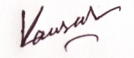

Kawsar Hossain Khan